**612/3**

**IPS ART & CRAFTS**

**Paper 3**

**Jul/Aug 2016**

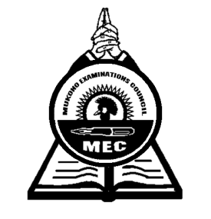**3 hours**

**MUKONO EXAMINATIONS COUNCIL**

**Uganda Certificate of Education**

IPS ART AND CRAFTS

DRAWING/PAINTING FROM HUMAN FIGURE

Paper 3

**3hours**

**Alternative subjects**

**EITHER** (Full figure)

1. On the floor before the candidates, place a mat half way folded. On it, a model sits bare footed facing the candidates dressed in a pair of shorts and a vest. The right leg is folded at the knee with its foot firmly placed on the mat. The right elbow rests on the right knee while the hand dangles with fingers dropping freely downwards.

The left leg folds and horizontally rests on the mat with its heal touching the other of the right leg. The model’s left arm vertically supports the body with its palm touching the mat.

**OR**  (Portrait)

1. A model dressed in a shirt with folded sleeves at the elbow faces candidates and sits behind the table. The model rests both elbows on the table with fists supporting the chin. The head is bent slightly facing down at the open newspaper in between elbows on the table.

***End -***